**20230123**

Please refer to ‘20230123 markups’ for Council changes.

We need to add 22.5° pitched roofs to the 1st floors with 450 eaves with some gable ends (as shown on markup)

Once changes are done, please update cover page pic, DR, streetscape, roof plan, garden, pos, roof plan, WSUD plan (we will update the report but adjust the roof) bess plan, 3d’s & shadow diagrams.

Please update D1 area analysis and update site analysis overall.

**20230123**

Did changes as per mark ups on GF, Roof Plans, roofs.

**20230124**

GF complete. Did Site Analysis, Areas, Garden Area, POS plan. Did gutters. Roofs is in progress.

**20230125**

Updated streetscape and FF windows. Added external shading devices. Did DR, shadows and roof model.

Internal elevation is in progress.

**20230131**

Hey team, we spoke with Council and they advised we need to increase the setback on D1 fronting Hispano Drive. The end result will be that D1 B1 wall is at 7.5m.

I have marked up the drawing for where we need to take the space from. We need to take some space out of D2 & D3 entries (reducing overall width of those dwellings) and shift across D1. Then there is some internal adjustments to D1 to further pull in the B1 wall and meet 7.5m requirement.

Once the above is done, you can then pull out the D1 living/meals wall so that the setback there is 7.5m (bottom left corner wall dimension)

Please... do not forget to adjust upstairs accordingly. Where there the GF & FF walls are aligned, they must be stud on stud. Make sure D3 bathroom does not go over the easement line, reduce in width. Adjust roof.

Please check that the Garden & POS still work.

Finally, update the site & area analysis.

Thank-you!

**20230201 Balazs**

I moved the dwellings, as you asked. Remade roof and WSUD plan. Floor plans are in progress.

**20230202**

Thanks Balazs, I’ve done some partial markups for you “20230202 markups”.

Do you think you would be able to finalise it by tonight? At least the GF, FF, EL & 3D’s should be 100% for client to review. Take some time to go through each page, due to the complicated changes there’s a bit of cleaning up to do. I understand it was a big undertaking to change everything like that, so appreciate your efforts so far!

Don’t forget the site & area analysis

**20230202 Kata**

I moved the dwelling 1 to 7500 setback. Updated GF, FF, EL, 3D and site & area analysis. Rest plans are in progress to updated. Did changes as per all mark ups.

**20230203**

Thank-you! Don’t forget to include this section in the garden calculation, up to where it is 1m wide

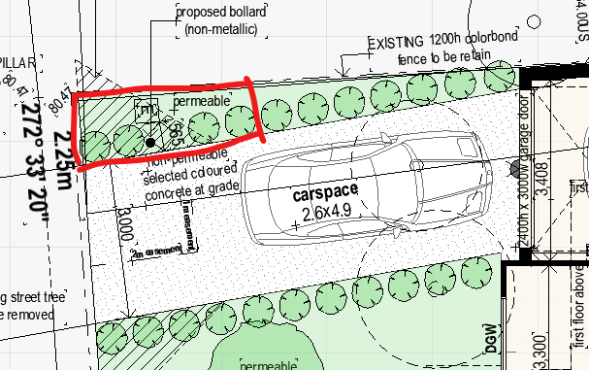

On the POS plan, can you please add the dimensions to the dark green POS. These areas marked are the only areas that can be counted in the <4m section of the calculation

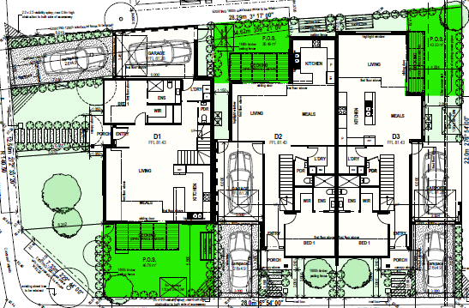

Also, I had to pull in (to the right) D2 kitchen wall 135mm. As we need 25m² POS. I’ve fixed FF roof but can you please update the ROOF & WSUD plans please.

Also moved the wall between D3 B3 & B4 to the left so that I could get clear 3m in B3. Please fix ROOF & WSUD plans here also.

Please finalise and update the site and area analysis due to the changes I made. Thanks

**20230203**

Updated roof plan, WSUD plan, BESS plan, Shadows, DR, Garden Are plan, POS plan and areas and site analysis. Ready for check.

**20230206**

Some errors on the roof, the hips should always be 45 degree angles and eaves cannot go over the internal boundary lines. Please refer to the ‘20230206 markups” please also update all relevant drawings. I also pulled the D1 retreat wall out a little bit so please re-calculate the area for D1.

**20230206**

Updated WSUD plan, BESS plan and shadows.

Changed roof plan, but 45 degrees wasn't adecvate for the roof, where you marked up. Mark up with more details please, how would you like to make a 45 degrees roof mixed with 22,5 degree roofs.

**20230208**

I adjusted the roof, please do final updates as per 20230208 markups. I need these done today please. I also need an internal north elevation.

Please dimension all bedrooms.